SIMATS ENGINEERING (SAVEETHA SCHOOL OF ENGINEERING) Department of Computer Science and Engineering
ASSESSMENT TOOL 3 – Comparative Analysis
Course Code: | CSA06 | Course Title: | Design and Analysis of Algorithms
CO Assessed: | CO4: Articulation (BL4, BL5) | Assessment: | Assessment Tool 3 – Comparative Analysis
Weightage: | 10% of CIA | Total Marks: | 100
CO4 Statement: | Solve optimization problems using dynamic programming and greedy strategies.
Student Name: | VIGNESH.Y | Reg. No.: | 192524100
Section / Batch: | 2025 | Date: | 22/08/2026

Instructions to Students
• Answer the following question. Total Marks: 100.
• Analyze the given questions thoroughly before answering.
• Compare multiple aspects such as methods, results, advantages, and limitations clearly. • Critically evaluate the strengths, weaknesses, and implications with proper justification. • Present meaningful insights, interpretations, and well-supported conclusions from the comparisons.

Question Type | Focus Area | Questions
Comparative Analysis | Comparative analysis of Dynamic Programming and Greedy algorithms for optimization problems. | Q1

SECTION A – Comparative Analysis
Code of Conduct
I VIGNESH.Y(192524100) certify that this submission is my original work and that I have adhered to the guidelines specified for this assessment. I understand that any violation of academic integrity rules will result in disciplinary action.
Signature of the Student: VIGNESH.Y

Q1. Comparative Analysis of Dynamic Programming and Greedy Algorithms for Optimization Problems

1. Introduction
Dynamic Programming (DP) and Greedy algorithms are the two dominant paradigms used to solve optimization problems, where the goal is to find a solution that maximizes or minimizes some objective subject to constraints. Both build a solution incrementally, but they differ fundamentally in how much of the solution space they explore before committing to a choice. This comparative analysis examines their methods, results, advantages, and limitations using the Knapsack family of problems (0/1 Knapsack via DP and Fractional Knapsack via Greedy) as a concrete case study, then generalizes the findings to broader classes of optimization problems.
2. Method of Operation
Dynamic Programming: DP solves a problem by breaking it into overlapping subproblems, solving each subproblem once, and storing (memoizing) its result in a table so it is never recomputed. The final answer is built bottom-up from these stored subproblem solutions. This guarantees that every possible combination consistent with the problem's constraints is implicitly considered through the recurrence relation, e.g., in 0/1 Knapsack the recurrence dp[i][w] = max(dp[i-1][w], values[i-1] + dp[i-1][w-weights[i-1]]) considers both including and excluding each item at every capacity level.
Greedy: A Greedy algorithm makes the single locally optimal choice at each step — in Fractional Knapsack, this means always taking as much as possible of the item with the highest value-to-weight ratio — and never reconsiders that choice later. It never explores alternative branches or backtracks, which is what makes it fast but also what makes it risky when local optimality does not compose into global optimality.
3. Case Study Results — Knapsack Comparison
For items with weights [10, 20, 30] and values [60, 100, 120] and capacity 50: the 0/1 Knapsack solved via DP selects items 2 and 3 in whole, yielding a maximum value of 220. The Fractional Knapsack solved via Greedy sorts items by value/weight ratio (6.0, 5.0, 4.0), takes items 1 and 2 fully, and takes 0.67 of item 3, yielding a maximum value of 240. The two methods disagree because Greedy is permitted to split item 3, an option unavailable to the 0/1 formulation; the 240 value is only optimal for the fractional variant of the problem, not the 0/1 variant, for which 220 is provably the true optimum.

4. Comparison Across Multiple Aspects
Aspect | Dynamic Programming | Greedy
Decision making | Considers all valid combinations via subproblem table; commits only after evaluating alternatives | Commits immediately to the locally best option at each step, never revisits
Optimality guarantee | Guaranteed optimal whenever the problem has optimal substructure and overlapping subproblems (e.g., 0/1 Knapsack) | Guaranteed optimal only when the problem also satisfies the greedy-choice property (e.g., Fractional Knapsack, Kruskal's/Prim's MST, Huffman coding)
Time complexity | Typically pseudo-polynomial or polynomial in the subproblem table size, e.g., O(n × capacity) for 0/1 Knapsack | Usually O(n log n) dominated by an initial sort, e.g., Fractional Knapsack
Space complexity | Higher — requires a table of size proportional to the number of subproblems (can be reduced with rolling arrays) | Lower — typically O(n) or O(1) auxiliary space beyond the input
Result on this case study | 220 (exact optimum for 0/1 Knapsack) | 240 (exact optimum for Fractional Knapsack only; not valid for 0/1)
Failure mode | None for problems with optimal substructure; mainly a performance/memory concern | Can converge to a suboptimal answer when applied to a problem lacking the greedy-choice property, as shown by its 240 not being valid for the 0/1 case

5. Critical Evaluation — Strengths and Weaknesses
Strengths of DP: Correctness is guaranteed for any problem with optimal substructure, and the same table can be reused to answer related queries (e.g., the optimal value for any smaller capacity is also available in the same DP table). This robustness is valuable when correctness cannot be sacrificed, such as financial allocation or resource-constrained scheduling with hard capacity limits.
Weaknesses of DP: The O(n × capacity) table becomes expensive when capacity is large (pseudo-polynomial, not truly polynomial in the input size, since capacity is a number whose value, not its bit-length, drives the cost), and the implementation is more complex, requiring careful table construction and backtracking logic to recover the actual chosen items.
Strengths of Greedy: Extremely fast and memory-light, with a simple, easy-to-implement decision rule. This makes it ideal for real-time or resource-constrained systems (e.g., fractional resource allocation, job sequencing, and Huffman coding, where the greedy-choice property provably holds).
Weaknesses of Greedy: It offers no correctness guarantee outside problems that satisfy the greedy-choice property; applying it to 0/1 Knapsack silently produces a value (240) that looks like a valid answer but is not achievable under the actual whole-item constraint, which is a dangerous failure mode because the algorithm does not signal that it may be wrong.
6. When Greedy Provides Optimal Results vs. When DP Is Necessary
Greedy is optimal when: the problem exhibits the greedy-choice property (a locally optimal choice is always part of some globally optimal solution) together with optimal substructure — examples include Fractional Knapsack, Minimum Spanning Tree (Kruskal's/Prim's), Huffman encoding, and activity/interval scheduling.
DP is necessary when: choices interact combinatorially and a locally best choice can block a better global solution, as in 0/1 Knapsack, Longest Common Subsequence, Matrix Chain Multiplication, and shortest paths with negative edges (Bellman-Ford) — problems where an exhaustive-but-efficient exploration of subproblems is required to certify optimality.
7. Synthesis and Insights
The Knapsack case study crystallizes a general principle in optimization algorithm design: the correctness of Greedy is not a property of the algorithm's cleverness but of the problem's structure — the same ratio-based greedy rule that is provably optimal for Fractional Knapsack becomes only an approximation, with no optimality guarantee, the moment the divisibility assumption is removed in 0/1 Knapsack. This means algorithm selection should start from proving (or disproving) the greedy-choice property for the specific problem at hand, rather than from the apparent similarity of two problems' descriptions. Practically, this suggests a two-stage design approach: attempt to establish whether a Greedy strategy is provably optimal for the problem class; if it cannot be established, default to Dynamic Programming, accepting its higher computational cost as the price of a correctness guarantee. In performance-critical systems, a hybrid approach is also common — using Greedy as a fast heuristic to obtain a first approximate solution, and reserving DP (or DP-based refinement) for cases where an exact optimum is required or where the Greedy result can be cheaply verified against a DP bound.
8. Conclusion
Both Dynamic Programming and Greedy are indispensable tools for optimization problems, but they are not interchangeable. DP trades time and space for a universal optimality guarantee on problems with optimal substructure, while Greedy trades that guarantee for speed and simplicity, remaining correct only on the narrower class of problems that also satisfy the greedy-choice property. The Knapsack comparison — 220 (true optimum for 0/1) versus 240 (true optimum only for the fractional variant) — is a clear, quantitative demonstration that method selection must be driven by problem structure, not superficial resemblance between problem statements.

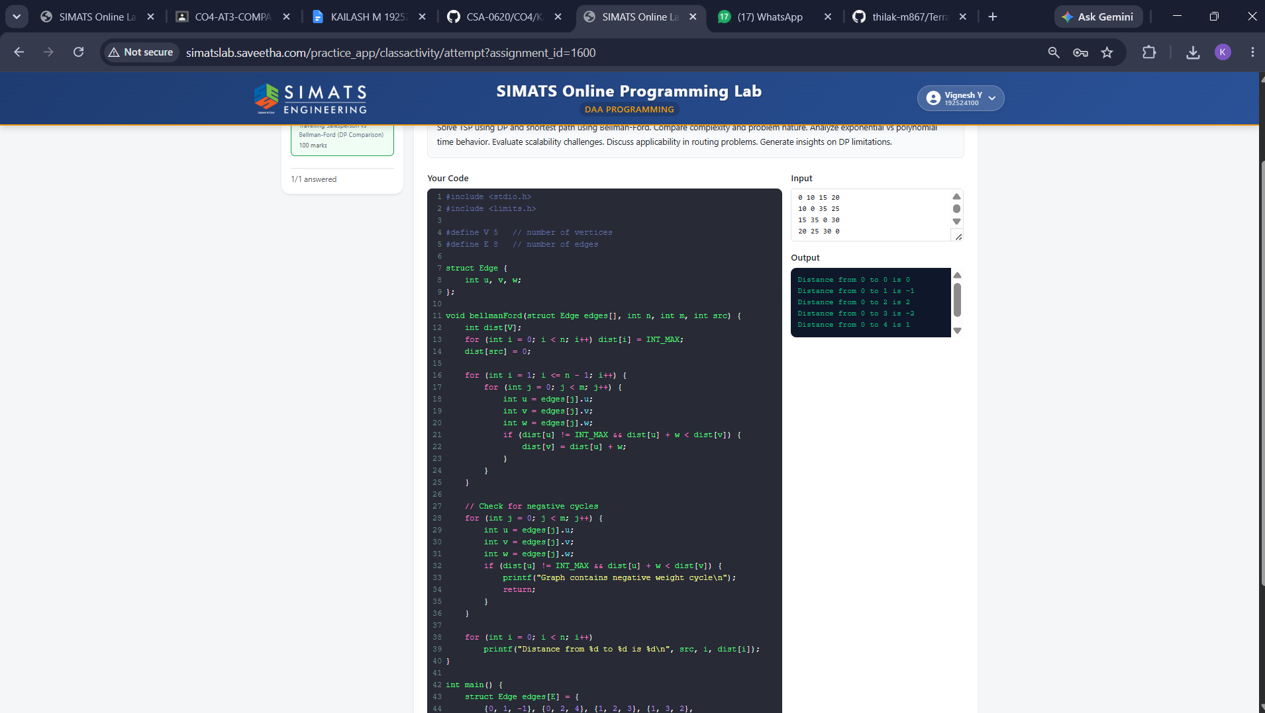

RUBRICS FOR CALCULATION
Comparative Analysis
Criteria | Weightage | Level 4 (Exemplary) | Level 3  (Proficient) | Level 2  (Developing) | Level 1  (Beginning)
Selection of  Studies/Parameters | 20% | Selects highly relevant and diverse studies with well-defined  comparison parameters | Selects relevant studies with minor gaps in parameter definition | Limited or  partially  relevant  selection | Poor or  inappropriate  selection of  studies
Comparison &  Differentiation | 25% | Clearly compares  multiple aspects  (methods, results,  limitations) with strong differentiation | Good comparison with minor gaps | Basic  comparison  with limited  depth | No clear  comparison;  mostly  descriptive
Critical Evaluation | 25% | Critically evaluates  strengths, weaknesses, and implications with strong justification | Provides  evaluation with  some justification | Limited  evaluation;  lacks depth | No critical  evaluation  provided
Synthesis & Insight Generation | 20% | Generates meaningful insights and conclusions from comparisons | Some insights  derived from  comparison | Limited or  unclear insights | No insights  generated
Clarity | 10% | Information is clearly presented  (tables/figures) with logical structure | Generally clear  with minor issues | Presentation  lacks clarity or structure | Poor  presentation and difficult to  understand

Marks Evaluation:
Criteria | Wt. | Level 4 –  Exemplary | Level 3 –  Proficient | Level 2 –  Developing | Level 1 –  Beginning
Selection of Studies/Parameters | 20%
Comparison & Differentiation | 25%
Critical Evaluation | 25%
Synthesis & Insight Generation | 20%
Clarity | 10%
Total Marks (100):

Faculty In-charge | Course Coordinator | Head of Department
Name: | Name: | Name:
Signature: _______________ | Signature: _______________ | Signature: _______________
Date: ___________________ | Date: ___________________ | Date: ___________________

